ST. XAVIER’S COLLEGE
(Affiliated to Tribhuvan University)
Maitighar, Kathmandu

LAB ASSIGNMENTS OF SYSTEM ANALYSIS AND DESIGN

SUBMITTED BY:
Kalakant Dahal
018BSCIT015

SUBMITTED TO:
Er. Rajan Karmacharya
Lecturer
Chief Technology Officer
Department of Computer Science

St. Xavier’s College
Maitighar, Kathmandu

Subject: System Analysis and Design

T.U. Regd. No.: Class Roll No. 018BSCIT015

Name of Student: Kalakant Dahal Year/Sem: 3rd / 5th

S. No. | Title | Signature
1 | DFD for Animal Park
2 | DFD for Video Rental Management System
3 | DFD for Food Ordering
4 | DFD for Hotel Reservation
5 | Use Case for Travel Agency Management System
6 | Use Case for Simple ATM System
7 | CPM Networks using project Libre

Theory:

Data flow diagram is a graphical representation of flow of data in an information system. It is capable of depicting incoming data flow, outgoing data flow and stored data. DFD can represent Source, destination, storage and flow of data using the following set of components -
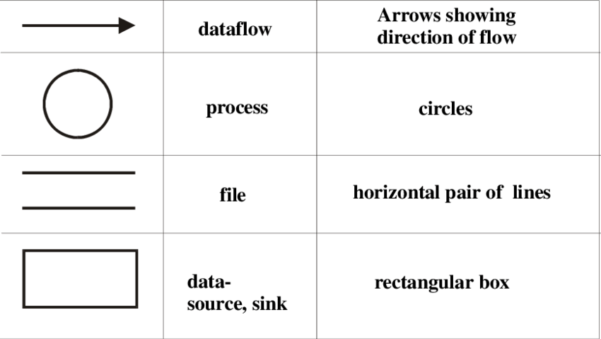

Figure: Symbol used in DFD

Levels of DFD
- Level 0 - Highest abstraction level DFD is known as Level 0 DFD, which depicts the entire information system as one diagram concealing all the underlying details. Level 0 DFDs are also known as context level DFDs.
- Level 1 - The Level 0 DFD is broken down into more specific, Level 1 DFD. Level 1 DFD depicts basic modules in the system and flow of data among various modules. Level 1 DFD also mentions basic processes and sources of information.
- Level 2 - At this level, DFD shows how data flows inside the modules mentioned in Level 1.
Higher level DFDs can be transformed into more specific lower level DFDs with deeper level of understanding unless the desired level of specification is achieved.

DATA FLOW DIAGRAM
ANIMAL PARK SYSTEM:
ENTITIES: Keeper, Head Keeper, Supplier, Head Staff
Keeper receives information from the system and keeps track of feeding of animals in the animal park. Head Keeper retrieves and maintains the records. Office staff keep track of food supply and orders in the system. Supplier supplies the orders he received from the system and generates receipts against it. DFD Level 1 expands process 1.0 where keeper queries records about animals, information about food, feeds animals and updates inventory accordingly. DFD Level 2 expands process 1.2 where keepers further queries records from animal DB and food DB.

CONTEXT DIAGRAM:
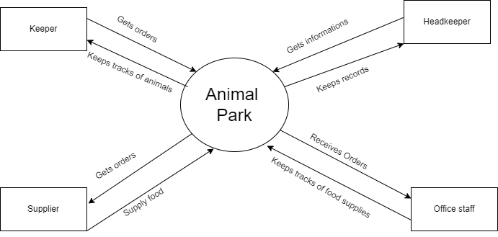

DFD LEVEL0:
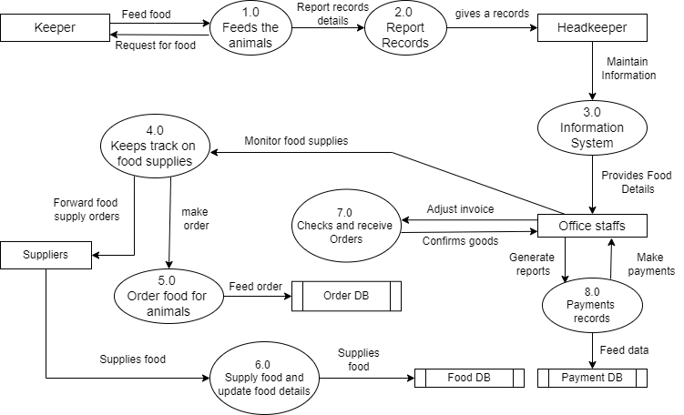
DFD LEVEL 1:
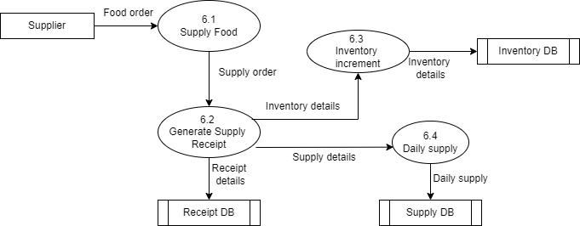

DFD LEVEL 2:
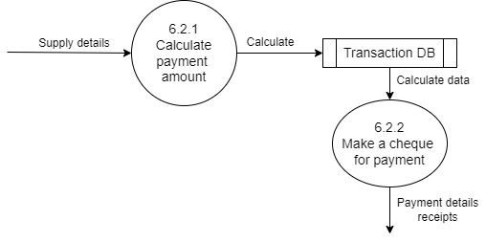

VIDEO-RENTAL LTD CASE STUDY
ENTITIES: Customer, Supplier, Store, Counter Staff
Customer borrows video from the store and the store lends the video. The store places orders to the supplier and the supplier in return supplies an invoice with the order. The counter staff issues membership cards to new customers and in return receives salary. DFD Level 1 expands process 1.0 where customer places customer order then receipt is generated and from order details updates DB. DFD Level 2 expands process 1.1 where customer places customer order, provides empty box with membership card and makes payment.
CONTEXT DIAGRAM
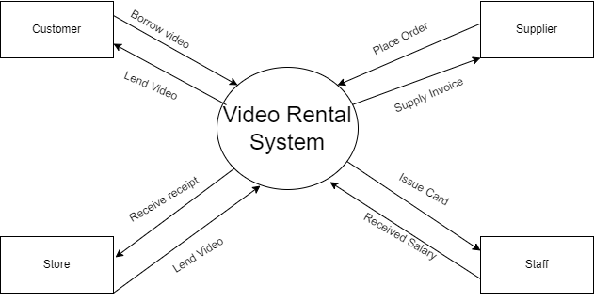

DFD level 0:
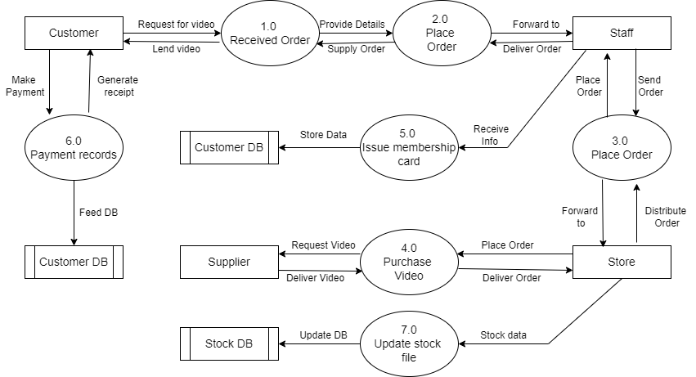

DFD level 1:
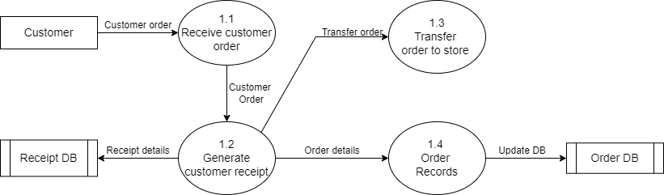
DFD level 2:
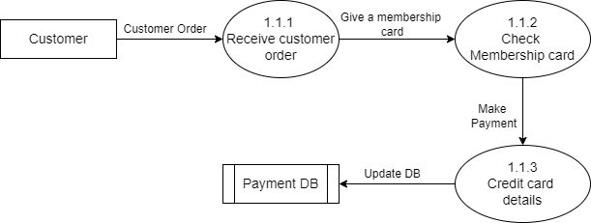

FOOD ORDERING SYSTEM:
ENTITIES: Customer, Manager, Waiter, Vendor, Kitchen
Customer places the order which is received by the waiter who transfers it to the kitchen. The kitchen then delivers the food to the waiter and then the waiter delivers it to the customer. Manager queries reports and vendor supplies the orders. DFD Level 1 expands process 1.0 where the customer places the order then the receipt is generated and order is transferred to the kitchen. The daily sales and inventory is also updated. DFD Level 2 expands process 1.1 where after the customer order, payment is calculated which is used to update transaction DB and receipt is printed.
CONTEXT DIAGRAM
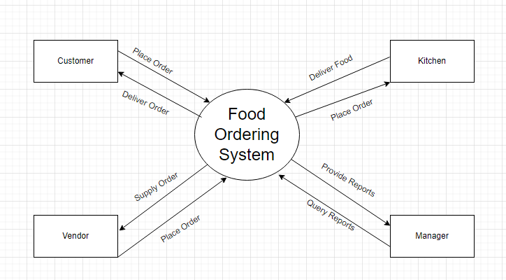
DFD LEVEL 0
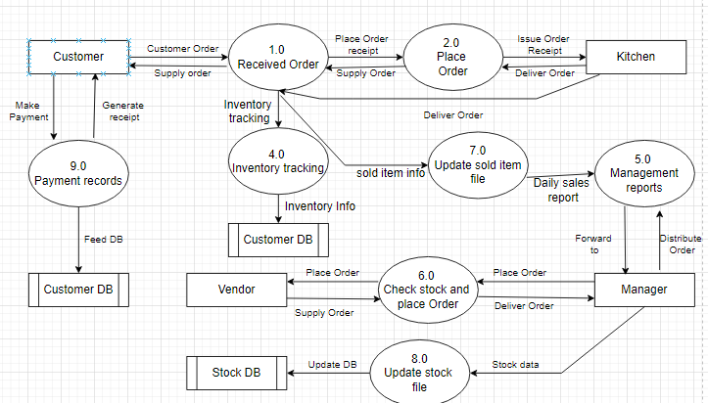

DFD LEVEL 1
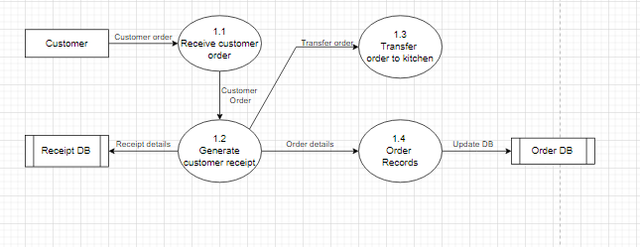
DFD LEVEL 2
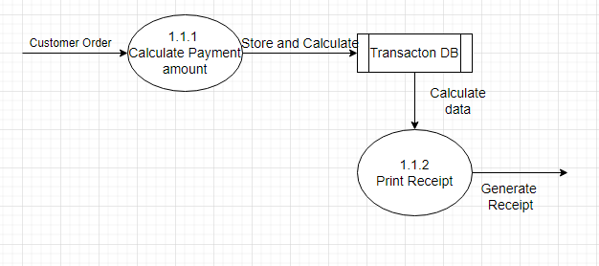

HOTEL RESERVATION SYSTEM:
ENTITIES: Customer, Kitchen, Employee, Manager.
Customer reserves a room and the employee makes the reservation for the customer. The customer in return receives different facilities and when it places food order, it is transferred to the kitchen. Manager grants permission for different activities. DFD Level 1 expands process 3.0 where employee checks for room availability and reservations and bills file is updated. DFD Level 2 expands process 3.1 where date of reservation, no of rooms to be reserved and other reservation details are checked.
CONTEXT DIAGRAM
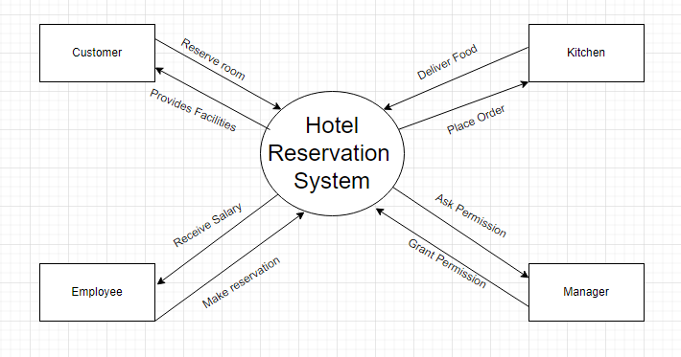
DFD LEVEL 0
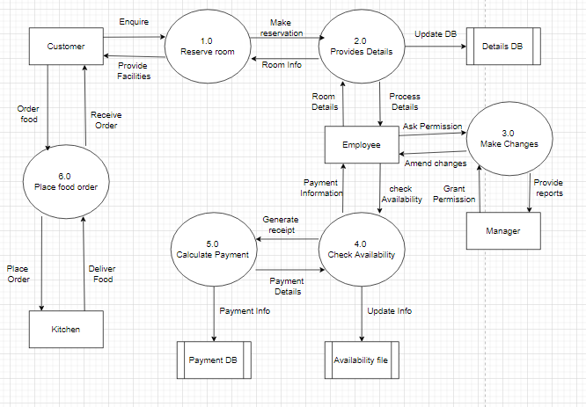
DFD LEVEL 1
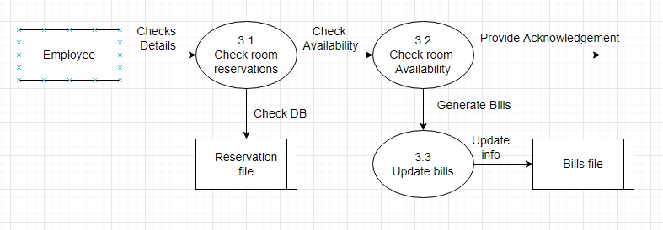
DFD LEVEL 2
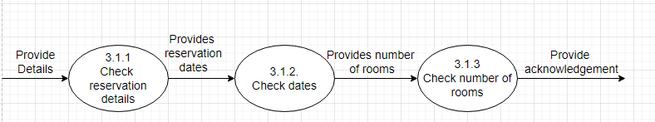

USE CASE STUDY
TRAVEL AGENCY MANAGEMENT SYSTEM
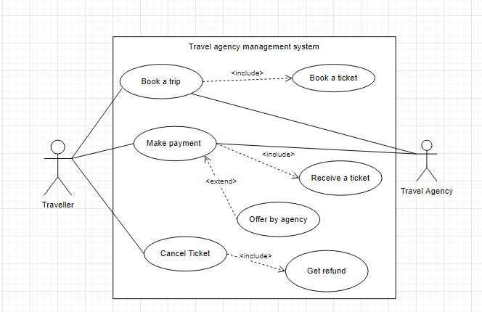
- The traveler can book a trip.
- The booking of the trip must be followed by the booking of the ticket.
- The traveler can make payment.
- The payment must be followed by the receipt of the ticket.
- The payment made by the traveler may receive an offer by the agency.
- The traveler can cancel the ticket.
- The cancellation of the ticket must be followed by the refund.

ATM SYSTEM
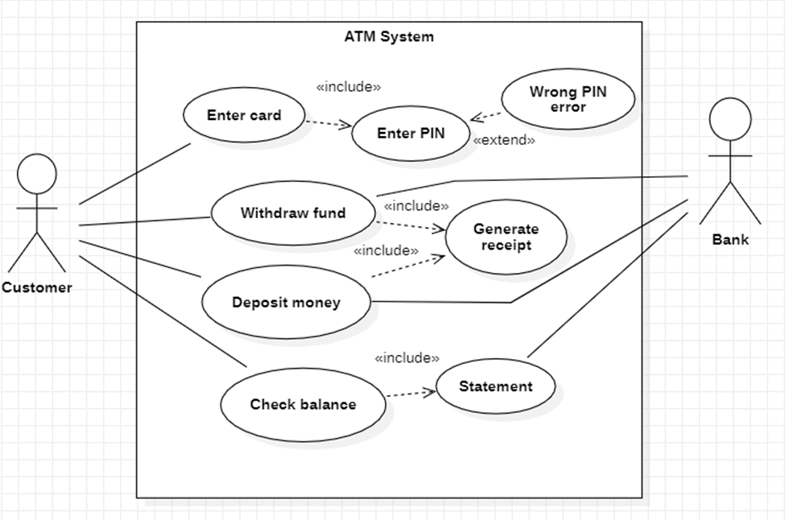
- The customer enters his/her card.
- The entering of the card must be followed by entering the PIN.
- After entering the PIN, the customer may be warned for a wrong PIN error.
- The customer can withdraw funds.
- The withdrawal of funds must be followed by generation of receipt.
- The customer can deposit money.
- The deposit of money must be followed by generation of receipt.
- The customer can check the balance.
- The checking of balance must be followed by a statement.

CPM Network Diagram
1.
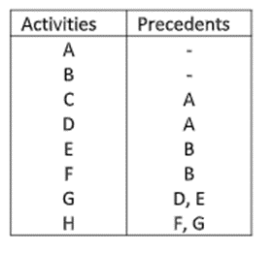
CORRESPONDING PROJECT-LIBRE FILE
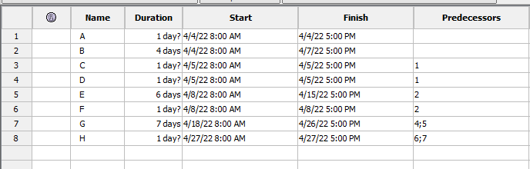
GANTT CHART
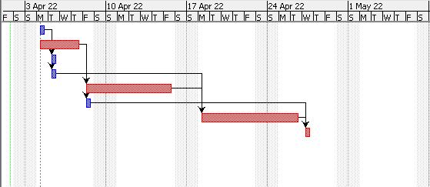

NETWORK DIAGRAM
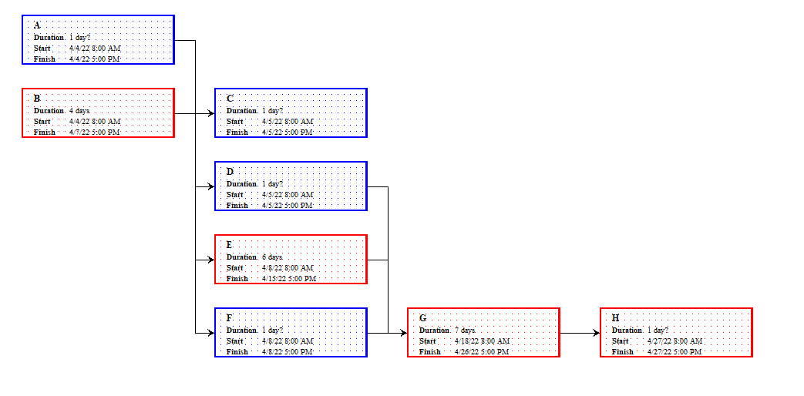CRITICAL PATH
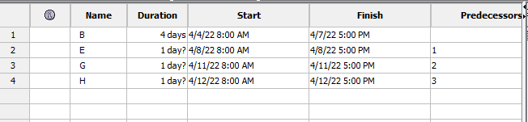

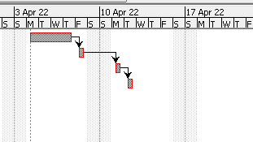

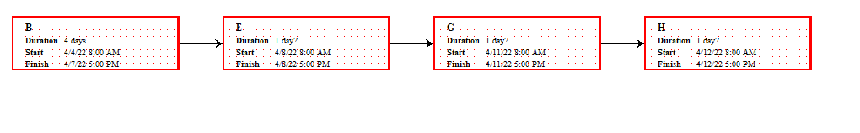
2.
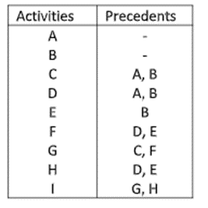

CORRESPONDING PROJECT-LIBRE FILE
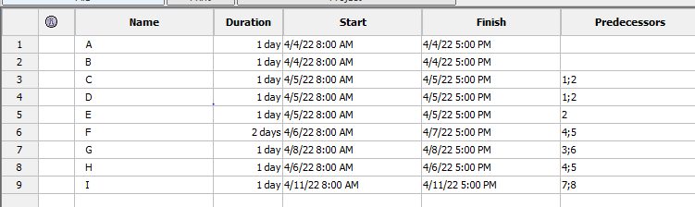

GANTT CHART
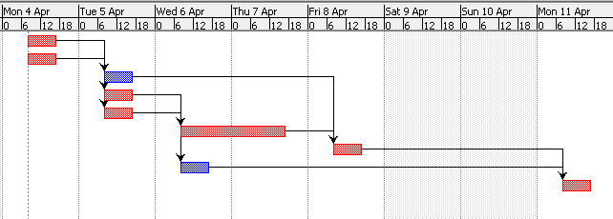

NETWORK DIAGRAM
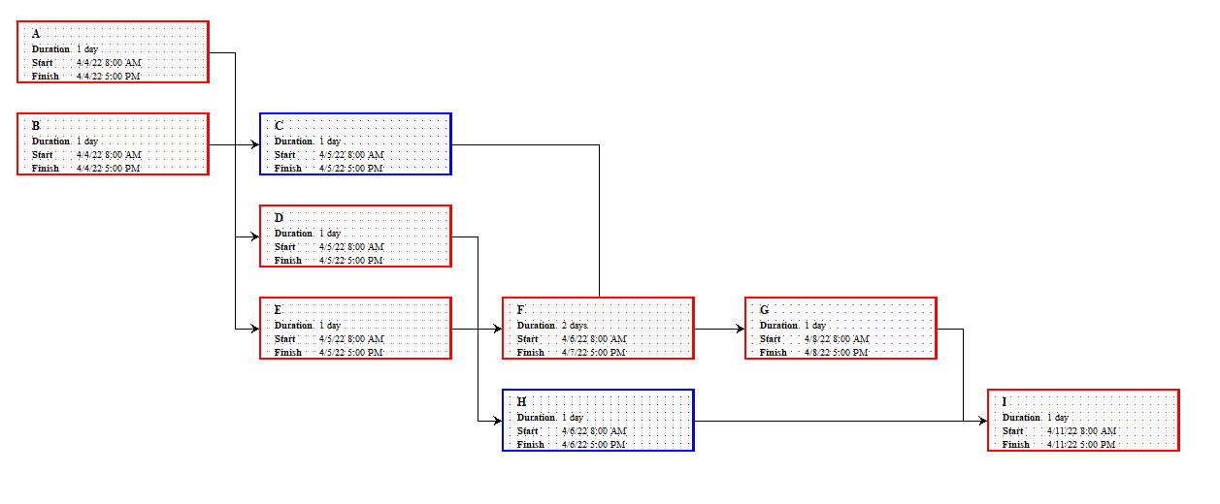

CRITICAL PATH
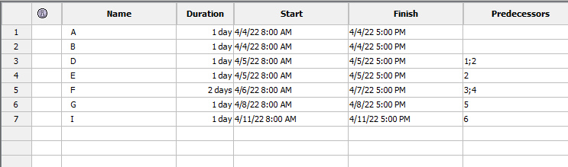
GANTT CHART
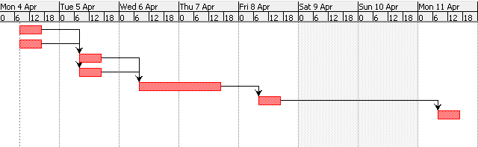
NETWORK DIAGRAM
